#### HANDS Workshop

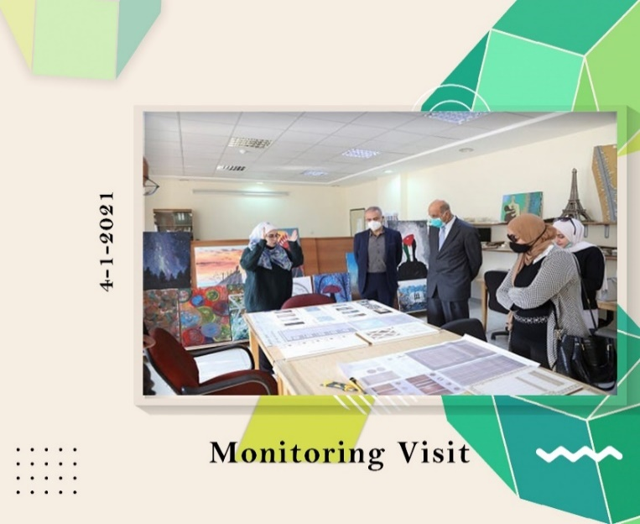**HANDS Monitoring with Jordanian National Erasmus Office**

**WP 7: QUALITY PLAN**

**Date:** Monday, 4/1/2021  
**Organizer:** Jordanian National Erasmus Office / ZUJ  
**Location:** Department of Architecture / Faculty of Architecture and Design at ZUJ

A monitoring visit assessed the HANDS project's progress at Al-Zaytoonah University. Dr. Dabbour presented overall status and implementation details for each partner university (JU, JUST, HU). Interviews with team members and students provided valuable feedback. Prof. Abu-El-Haija offered closing remarks, and a meeting with the University President solidified collaboration.